**Regression Output**

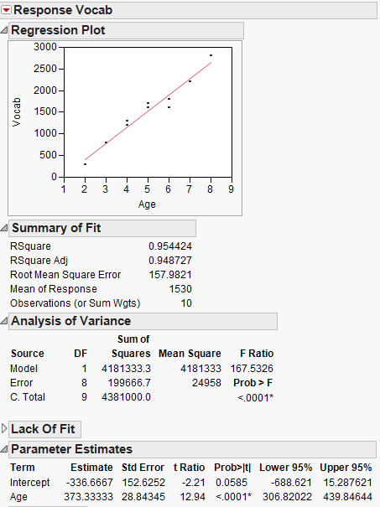

**Calculate $SD\left({\hat{β}}_{i}\right)$**

Recall that $SD\left({\hat{β}}_{1}\right)=$ $\sqrt{\frac{\frac{SSE}{n-2}}{\sum_{i=1}^{n}{{\left(x_{i}-\overline{x}\right)}^{2}}}}=\frac{{\hat{σ}}_{ε}}{\sqrt{\sum_{i=1}^{n}{{\left(x_{i}-\overline{x}\right)}^{2}}}}=\frac{s}{\sqrt{\sum_{i=1}^{n}{{\left(x_{i}-\overline{x}\right)}^{2}}}}$

First, let’s calculate the numerator, *s*:

Here, SSE = 199666.7 and n = 10.

$${{\hat{σ}}_{ε}}^{2}=s^{2}=\frac{SSE}{n-2}=\frac{199666.7}{8}=24958.34$$

$$s=\sqrt{24958.34}=157.9821$$

Now, let’s calculate the denominator.

Looking at the data, $\sum_{i=1}^{n}{{\left(x_{i}-\overline{x}\right)}^{2}}=30$.

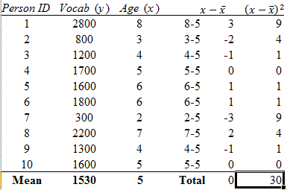

Then, $\sqrt{\sum_{i=1}^{n}{{\left(x_{i}-\overline{x}\right)}^{2}}}$ = $\sqrt{30}=$ 5.47723.

So, $SD\left({\hat{β}}_{1}\right)=$ $\frac{s}{\sqrt{\sum_{i=1}^{n}{{\left(x_{i}-\overline{x}\right)}^{2}}}}=\frac{157.9821}{5.47723 }=28.84345$

Compare with JMP output:



Let’s do the same thing for $SD\left({\hat{β}}_{0}\right)$. Recall that

$$SD\left({\hat{β}}_{0}\right)=\sqrt{\frac{SSE}{n-2}}∙\sqrt{\frac{{\overline{x}}^{2}}{\sum_{i=1}^{n}{{\left(x_{i}-\overline{x}\right)}^{2}}}+\frac{1}{n}}=s\sqrt{\frac{{\overline{x}}^{2}}{\sum_{i=1}^{n}{{\left(x_{i}-\overline{x}\right)}^{2}}}+\frac{1}{n}}$$

We can use the information above to plug it into the formula:

$$SD\left({\hat{β}}_{0}\right)=s\sqrt{\frac{{\overline{x}}^{2}}{\sum_{i=1}^{n}{{\left(x_{i}-\overline{x}\right)}^{2}}}+\frac{1}{n}}=157.9821\sqrt{\frac{5^{2}}{30}+\frac{1}{10}}=152.6252$$

Compare with JMP Output:



**Hypothesis Testing for $β_{i}$**

$${H_{0}: β}_{i}=0 (for i=0 and 1)$$

${H_{a}: β}_{i}≠0$ $(for i=0 and 1)$

Recall that ${\hat{β}}_{0}$ and ${\hat{β}}_{1}$ are sample statistics which are point estimators of the true (and unknown) population parameters $β_{0}$ and $β_{1}$, respectively. Because ${\hat{β}}_{0}$ and ${\hat{β}}_{1}$ are statistics, they have sampling distributions, and it is known that the quantity

$T=\frac{{\hat{β}}_{i}-E\left({\hat{β}}_{i}\right)}{SD\left({\hat{β}}_{i}\right)}$

has a t-distribution with *n – 2* degrees of freedom.

When $H_{0}$ is true and $β_{i}=0$, the formula for *T* above reduces to

$$T_{i}=\frac{{\hat{β}}_{i}-E\left({\hat{β}}_{i}\right)}{SD\left({\hat{β}}_{i}\right)}=\frac{{\hat{β}}_{i}-0}{SD\left({\hat{β}}_{i}\right)}=\frac{{\hat{β}}_{i}}{SD\left({\hat{β}}_{i}\right)}$$

Specifically, for ${\hat{β}}_{0}$,

$$T_{0}=\frac{{\hat{β}}_{0}}{SD\left({\hat{β}}_{0}\right)}=\frac{{\hat{β}}_{0}}{\sqrt{\frac{SSE}{n-2}}∙\sqrt{\frac{{\overline{x}}^{2}}{\sum_{i=1}^{n}{{\left(x_{i}-\overline{x}\right)}^{2}}}+\frac{1}{n}}}$$

And for ${\hat{β}}_{1}$,

$$T_{1}=\frac{{\hat{β}}_{1}}{SD\left({\hat{β}}_{1}\right)}=\frac{{\hat{β}}_{1}}{\sqrt{\frac{\frac{SSE}{n-2}}{\sum_{i=1}^{n}{{\left(x_{i}-\overline{x}\right)}^{2}}}}}$$

In our case,

$$T_{0}=\frac{{\hat{β}}_{0}}{SD\left({\hat{β}}_{0}\right)}=\frac{-336.6667}{152.6252}=-2.21$$

The p-value corresponding to $T_{0}=-2.21$ with *n – 2* = 8degrees of freedom and *α* = 0.05 may be obtained from Excel by entering: *=TDIST(ABS(-2.21),8,2)*. The resulting p-value is 0.0581. Compare these results ( $T_{0}$ and p-value) with the corresponding results from JMP:



Ultimately, we are *not* able to reject ${H_{0}: β}_{0}=0$ for ${H_{a}: β}_{0}≠0$ because p-value > α = 0.05.

Said differently, *p* = 0.0585 is the probability of having a sample where ${\hat{β}}_{0}$ is at least $-336.6667$ units, or *words*, away from 0 when the true value of $β_{0}$ in the population is 0. That is, it seems that (because of the large standard error) it’s not that unlikely to get such a value of ${\hat{β}}_{0}$ when $β_{0}$ = 0.

Similarly,

$$T_{1}=\frac{{\hat{β}}_{1}}{SD\left({\hat{β}}_{1}\right)}=\frac{373.33333}{28.84345}=12.94$$

The p-value corresponding to $T_{1}=12.94$ with *n – 2* = 8degrees of freedom and *α* = 0.05 may be obtained from Excel by entering: *=TDIST(12.94,8,2)*. The resulting p-value is 0.0000012. Compare these results ( $T_{1}$ and p-value) with the corresponding results from JMP:



Ultimately, we are able to reject ${H_{0}: β}_{1}=0$ for ${H_{a}: β}_{1}≠0$ because p-value < α = 0.05.

Said differently, *p* = 0.0000012 is the probability of having a sample where ${\hat{β}}_{1}$ is at least $373.33333$ when the true value of $β_{1}$ in the population is 0. In the context of this problem, age is a statistically significant predictor of vocabulary in children.

**Confidence Intervals for $β_{i}$**

We can also calculate the 95% confidence intervals for $β_{1}$ and $β_{0}$.

For a 95% confidence interval, the formula is

$${\hat{β}}_{i}±t_{0.025, n-2}∙SD\left({\hat{β}}_{i}\right)$$

Specifically, for $β_{1}$, the 95% CI is:

$${\hat{β}}_{1}±t_{0.025, n-2}∙SD\left({\hat{β}}_{1}\right)={\hat{β}}_{1}±t_{0.025, n-2}∙\sqrt{\frac{\frac{SSE}{n-2}}{\sum_{i=1}^{n}{{\left(x_{i}-\overline{x}\right)}^{2}}}}$$

And for $β_{0}$, the 95% CI is:

$${\hat{β}}_{0}±t_{0.025, n-2}∙SD\left({\hat{β}}_{0}\right)={\hat{β}}_{0}±t_{0.025, n-2}∙\left(\sqrt{\frac{SSE}{n-2}}∙\sqrt{\frac{{\overline{x}}^{2}}{\sum_{i=1}^{n}{{\left(x_{i}-\overline{x}\right)}^{2}}}+\frac{1}{n}}\right)$$

For our sample, $t_{0.025, n-2}$ (where in our case *n* = 10),may be computed with the Excel formula *=TINV(0.05,8)* = 2.306.

Plugging in all the values into the formula, the confidence intervals we get for $β_{1}$ and $β_{0}$ are, respectively,

$${\hat{β}}_{1}±t_{0.025, n-2}∙SD\left({\hat{β}}_{1}\right)=373.33333±2.306∙28.8435=(306.82,439.85)$$

$${\hat{β}}_{0}±t_{0.025, n-2}∙SD\left({\hat{β}}_{0}\right)=-336.6667±2.306∙152.6252=(-688.62, 15.29)$$

Check the corresponding results in JMP:



Confidence intervals give plausible values for $β_{1}$ and $β_{0}$. That is, we’re 95% confident that $β_{1}$ is between 306.82 and 439.85. Because 0 is not part of the interval, it’s not a likely value for $β_{1}$. This is not surprising, because we rejected ${H_{0}: β}_{1}=0$ for ${H_{a}: β}_{1}≠0$ at *α* = 0.05.

Furthermore, we are 95% confident that $β_{0}$ is between -688.621 and 15.288. Because 0 *is* part of the interval, it is a plausible value for $β_{0}$. This is not surprising, because we failed to reject ${H_{0}: β}_{0}=0$ for ${H_{a}: β}_{0}≠0$ at *α* = 0.05.